TITLE
Analysis of Mathematics Performance in JSS1 Students
OBJECTIVE
This study aims to analyze the performance of students in mathematics using statistical methods.
METHOD
The data was collected from student records and analyzed using Python. Descriptive statistics and visualizations such as histograms and boxplots were used.
RESULTS / FINDING
Mean Score :The average mathematics score for JSS1 students is approximately 54, indicating a moderate level of academic performance. This suggests that while students demonstrate a basic understanding of the subject, there is room for improvement.
BoxPlot
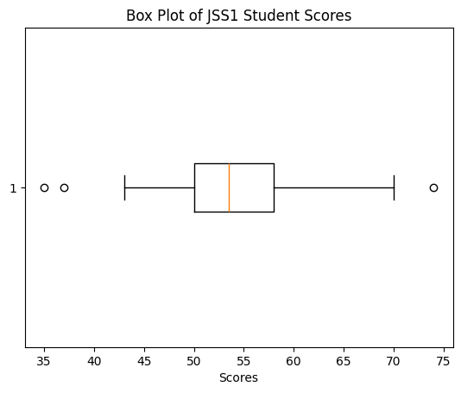
The boxplot analysis indicates that the median score is approximately 54, which is consistent with the mean, suggesting a fairly symmetrical distribution of scores. The majority of students scored within a narrow range of approximately 50 to 58, indicating relatively low variability among average-performing students. However, a few outliers are present on both the lower and upper ends of the distribution, highlighting the existence of both underperforming and high-achieving students.
Histogram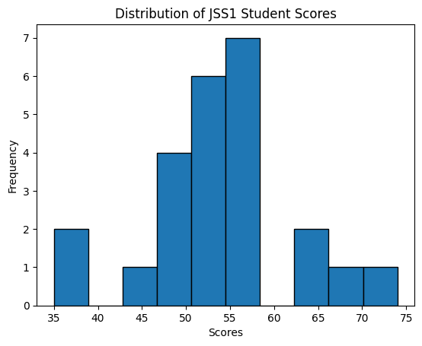The distribution of scores shows that most students scored between 50 and 60, indicating that the majority of students fall within the average performance range. There are relatively few students at both the lower and higher ends of the score spectrum, suggesting limited variation in extreme performance levels.
Conclusion
The average mathematics score for JSS1 students is approximately 54, indicating a moderate level of academic performance. The distribution of scores shows that most students fall between 50 and 60, suggesting that the majority of students are average performers. The boxplot further reveals that scores are fairly concentrated within a narrow range, with a few outliers on both the lower and higher ends. This indicates the presence of both struggling and high-performing students, highlighting disparities in academic performance.

